Working in the Cloud

with ClearMedia Academy

ClearMedia Bizzcloud: SAML authentication using Azure AD

This document will show you you how to setup vCloud SAML authentication using Azure AD.

As a prerequesit you need to have access to Azure AD Premium P2

1. Setting up Azure AD

**Adding an Enterprise application**

|  |  |
| --- | --- |
| First lets get started with configuring Azure AD. Once logged in to the Azure portal you will have to add an Enterprise application. To do so go to “Azure Active Directory‘” and select “Enterprise applications“. |  |
| Now click on “New application” and select “Non-galery application”.  Next give the application a name and click on “Add” to add the application. |  |

**Setting up Single sign on**

Select “SAML” to actually start the SAML configuration.

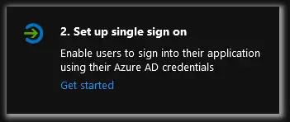

In the newly opened setup page add the metadate information from vCloud. This information is something that I can find in vCloud director by going to go to Administration –> Identity providers –> SAML

Now add the identity ID by clicking “Edit” and filling out the vCloud tenant URL as the id like so:

After saving you can download the Metadata by clicking on the Metadate link.

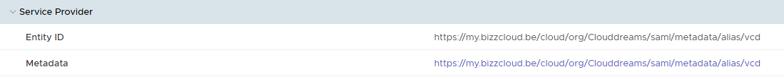

Now go back to the Azure portal and upload the Metadata information you just downloaded.  
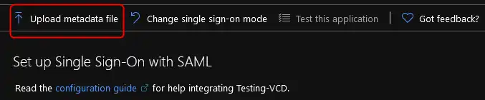

In the newly opened config sceen enter the location of the previsously downloaded file and click “Add“

Now you need to add some user/group parameters that vCloud can validate.You can do this by clicking on the “User Attributes & Claims” edit button.

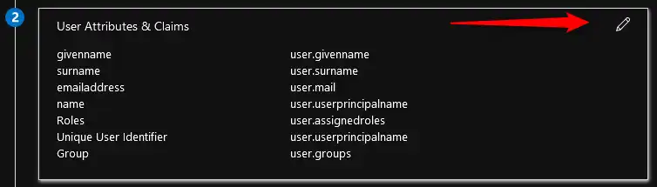

Here you have to add some additional claims. So click on “Add new claim” and add the “user.assignedroles” claim  
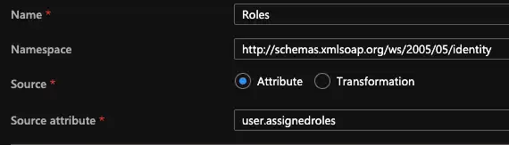

* Fill in the “Name” for the claim: Roles
* Fill in the “Namespace” for the claim: http://schemas.xmlsoap.org/ws/2005/05/Roles
* Select the user.assignedroles from the drop down menu for Source attribute and click “Save“

Next up is user.email

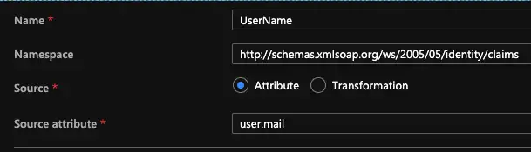

Fill in the “Name” for the claim: Username

Fill in the “Namespace” for the claim: http://schemas.xmlsoap.org/ws/2005/05/identity/claims/UserName

Select the user.email from the drop down menu for “Source attribute” and click “Save“

And finally add a “Group claim“.  
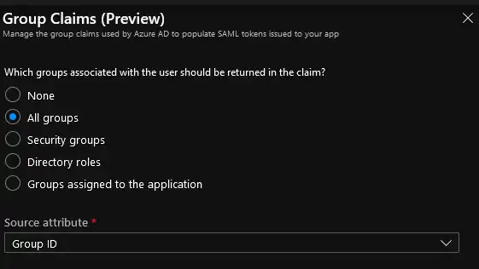

Select “All groups” and click “Save“

Now All you need to do is download the Azure AD metadata and import it into vCloud.

To do so go back to the “SIngle Sign on with SAML” by clicking on the link in Azure.  
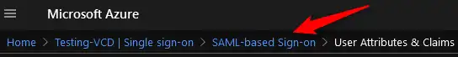

Now download the “Federation Metadata XML” file.

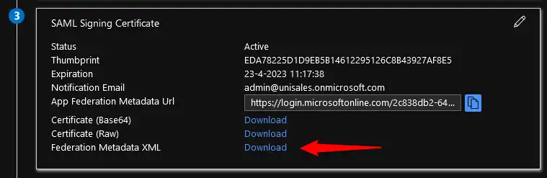

1. Setting up vCloud

Now that you’re done with the Azure AD part you can finish the config in Vcloud. To do this go back to the SAML configuration page and upload the metadata file you just downloaded.

**Administration** –> **Identity providers** –> **SAML - Edit–> Identity provider –> Enable the check box –>Upload metadate file –> Save**

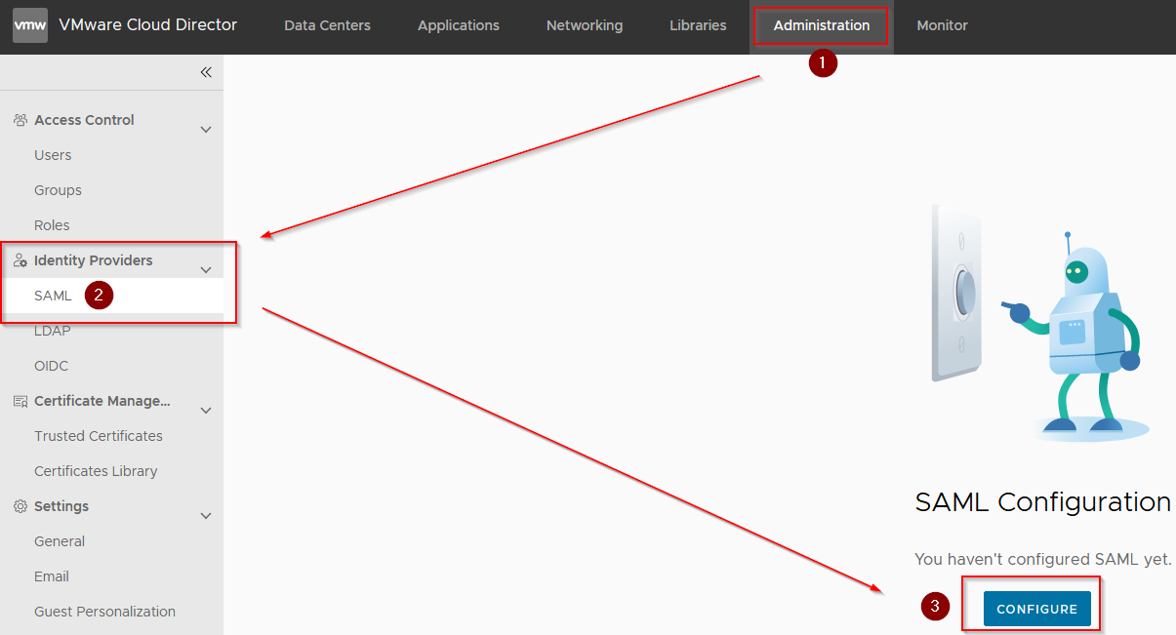

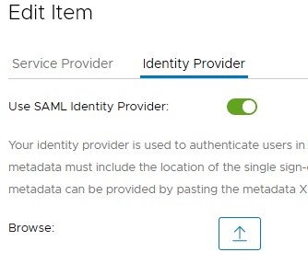

Now all that is left to do is to add the users and see if you can login to vCloud using Azure AD.

To do so go to “Users” and select “Import Users“

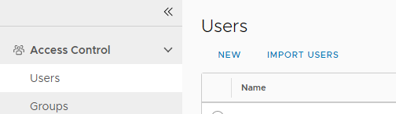

Now you have to add your users from Azure

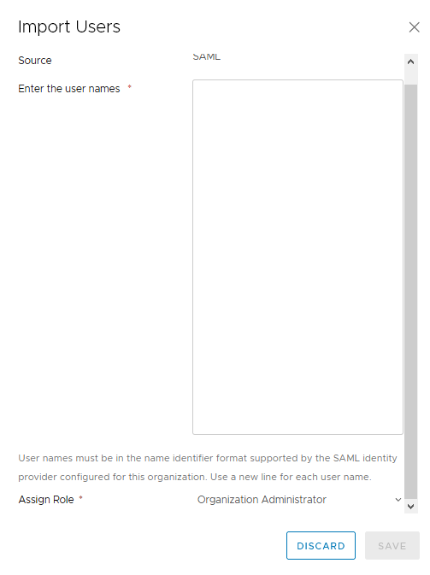

Enter the user name and select the Role for the user

Finaly test the login with the AzureAD User